**NAME : ADVITEEYA SHRAV**

1. write a program to prompt user to enter some name until entering Sai

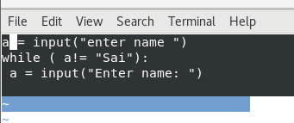

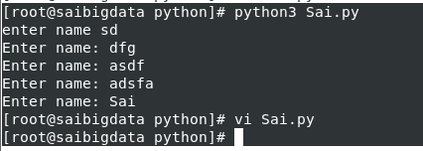

2. Write a Program to display *'s in Right Angled Triangled Form

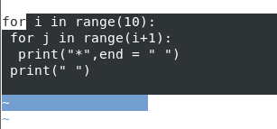

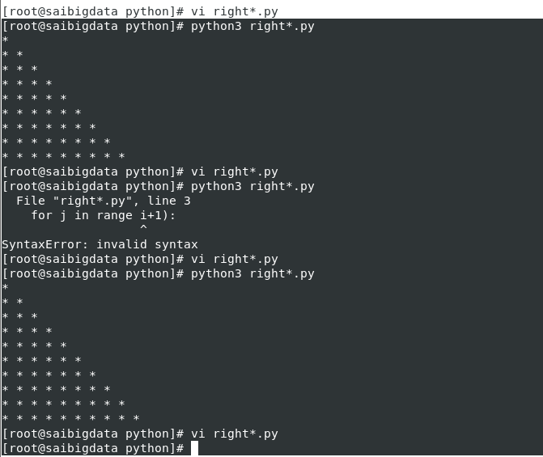

3. Write a Program to display *'s in Pyramid Style

(Also known as Equivalent Triangle)

